Image | 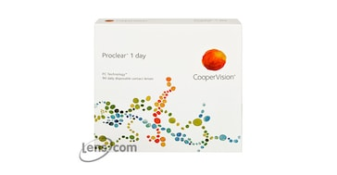
Brand | MICHEAL KORS
Model Name | PROCLEAR 1 DAY
Price | RS 2500
PRODUCT DETAILS

